MADHUMITHA M
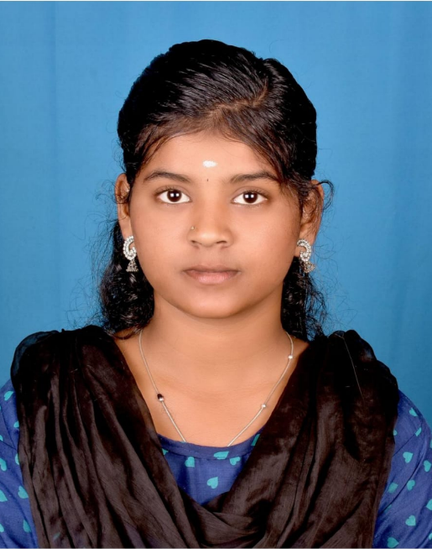

PHOTO
Contact No : +91 8015424001
Email ID: sumathymahal@gmail.com

CAREER OBJECTIVE
Enthusiastic Artificial Intelligence and Machine Learning engineering fresher with a strong foundation in Java and Python and hands-on practical exposure through academic projects. Eager to apply technical knowledge in a professional environment, learn industry practices, and contribute effectively while growing as a skilled developer

ACADEMIC PROFILE

Course | Institution | Board/University | year | percentage
B.E CSE(AI&ML) | Sethu Institute of Technology | Sethu institute of technology | 2023-2027 | 8.5
*percentage upto 6th semester

TECHNICAL SKILLS
Operating system :windows10,windows11,linux
Programming languages :java, python,full stack.
Tools : vs code,Figma,canva,XAMPP-local server

ACADAMIC PROJECTS
Title: AgriTech – AI & IoT Based Crop Recommendation System
Description: Developed an IoT-based smart agriculture system that monitors soil quality parameters using sensors and microprocessors. Applied AI and Machine Learning techniques to analyze threshold values and recommend suitable crops. Led the project team and coordinated hardware–software integration.
Title: Institutional Bus Tracker with Biometric Attendance
Description: Designed a real-time bus tracking system integrated with a mobile application and biometric authentication. Enabled users to track bus location and mark attendance, improving transparency, safety, and attendance management within the institution.
Title: Women Safety Application
Description: Developed a smart women safety application with automatic anomaly detection. The system triggers emergency actions such as video recording, live location sharing, and alert notifications without manual intervention, ensuring rapid response during critical situations.
Title: PYROPURE
Description: Developed a hybrid mechanical, biological, and chemical air purification system designed for fire accident scenarios. Integrated IoT hardware and AI/ML techniques to enhance air quality monitoring and purification efficiency. Focused on real-time response and safety enhancement.

INTERNSHIP
Attended the internship on MACHINE LEARNING WITH PYTHON conducted by IUNOWARE PRIVATE LMTD (27-05-2025 to 16-06-2025)
Attended and completed a structured 5-level internship on IOT TECHNOLOGIES conducted by e-Yantra.

AREA OF INTERESTS
- Java development
- Python development
- Full stack development
- MySQL
- Bootstrap
- UI/UX design (Figma)
- Advanced Javascript
- Artificial Intelligence
- Machine Learning
- Data Science

ACHIEVEMENTS
- I am certified as a Full stack developer
- I am certified as a Java developer
- Completed a course on Generative Artificial Intelligence and Machine Learning at Rinex Technologies
- Completed a course on Robotic Technology at E-Yantra

EXTRA CURRICULAR
- Member of Initiative club
- Member of Rotract club
- Department student incharge of Womens club at sethu institute of technology
- Served as Team Leader of the Scouts and Guides unit at AGMHSS.

KEY STRENGTH
- Flexibility and Adaptability
- Ability to stay calm and focused under pressure
- Attention to details
- Ability to learn

HOBBIES
- Learning new technologies via online platforms
- Gardening.
- Cooking

PERSONAL DETAILS
Name : Madhumitha M
Father name : Mahalingam B
Date of birth :03/09/2005
Gender : Female
Marital status : Single
Nationality : Indian
Language known : Tamil(read & write), English(read&write), Telugu(speak),Hindi(Read)

DECLARATION
I here by declare that all the information mentioned above is true to my knowledge and I bear the responsibility for the above mentioned particulars.

PLACE:
DATE: SIGNATURE

